PROBLEM 3.46

KNOWN: Tube diameter and refrigerant temperature for evaporator of a refrigerant system. Convection coefficient and temperature of outside air.

FIND: (a) Rate of heat extraction without frost formation, (b) Effect of frost formation on heat rate, (c) Time required for a 2 mm thick frost layer to melt in ambient air for which h = 2 W/m²⋅K and 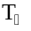 = 20°C.

SCHEMATIC:
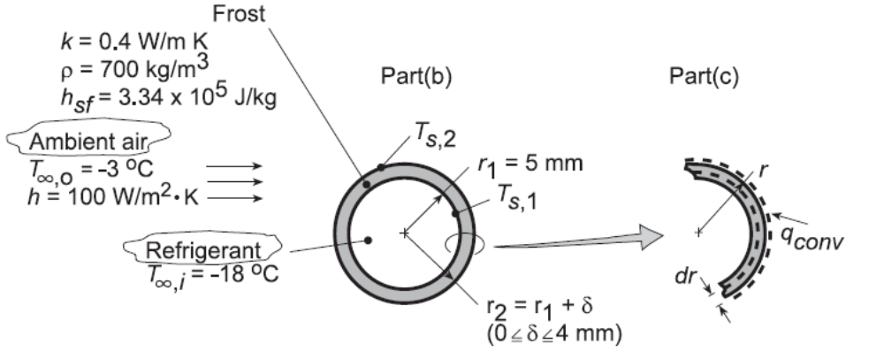

ASSUMPTIONS: (1) One-dimensional, steady-state conditions, (2) Negligible convection resistance for refrigerant flow 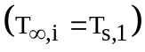, (3) Negligible tube wall conduction resistance, (4) Negligible radiation exchange at outer surface.

ANALYSIS: (a) The cooling capacity in the defrosted condition (δ = 0) corresponds to the rate of heat extraction from the airflow. Hence,
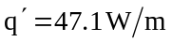 <
(b) With the frost layer, there is an additional (conduction) resistance to heat transfer, and the extraction rate is
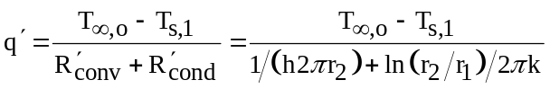
For 5 ≤ r₂ ≤ 9 mm and k = 0.4 W/m⋅K, this expression yields
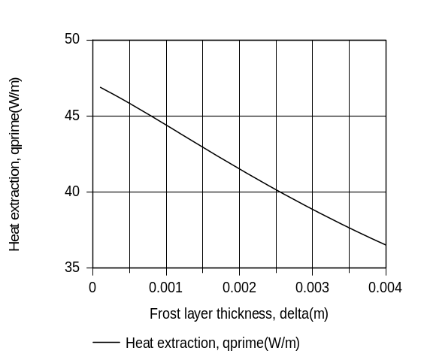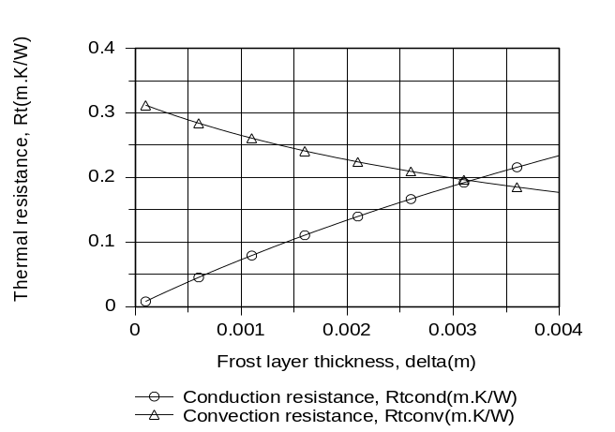

Continued...
PROBLEM 3.46 (Cont.)

The heat extraction, and hence the performance of the evaporator coil, decreases with increasing frost layer thickness due to an increase in the total resistance to heat transfer. Although the convection resistance decreases with increasing δ, the reduction is exceeded by the increase in the conduction resistance.

(c) The time t_{m} required to melt a 2 mm thick frost layer may be determined by applying an energy balance, Eq. 1.12c, over the differential time interval dt and to a differential control volume extending inward from the surface of the layer.

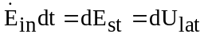

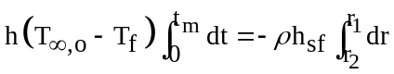

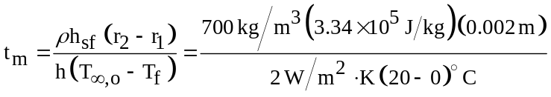
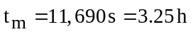 <

COMMENTS: The tube radius r₁ exceeds the critical radius r_{cr} = k/h = 0.4 W/m⋅K/100 W/m²⋅K = 0.004 m, in which case any frost formation will reduce the performance of the coil.

